(4 marks, file to be edited: Q1.cpp)
Notes: (1) You can create new function(s) if you see it is necessary. (2) In the main function: (a) Do not edit given statements. (b) Write statements in the indicated area only. (3) Suppose that a user enter data correctly, thus you do not need to write code to check input.

TC1 (1 mark):
There are 4 variables a, b, c and s already declared. Calculate s = min(a,b,c).

Sample output:

TC2 (3 marks):
Enter data for 2 given integer variables m and n. Calculate the sum s as below:
if n < m then s = n!. E.g. if m = 20 and n = 5 then s = 5! = 120
otherwise (i.e. n ≥ m)
s = sum of square numbers in the interval [m, n]. E.g. if m = 4 and n = 16 then s = 4 + 9 + 16 = 29 . (A square number is an integer that is the square of an integer, e.g 16 is square number because 16 = 4*4)

Sample output:
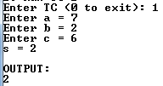 | 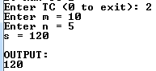 | 